**Experiment -1.1**

**Student Name:Parikshit sharma UID:19BCS4520**

**Branch:CSE-IOT-1 Section/Group IOT-1/A**

**Semester: 4th Date of Performance:02/09/2021**

**Subject Name :Project based learning in java lab**

**Subject Code:CSP-296**

**1. Aim/Overview of the practical:**

Create an application to save the employee information using arrays having following fields:-

empid[],depName[],empDes,empName[],dateJoin[],basic[],hra[],it[], Des Codes [].

Tasks:-1 Salary should be calculated as (Basic+HRA+DA-IT)

Task:- 2 Printing designation and da according to employee designation

**2. Task to be done:**

Tasks:-1 Salary should be calculated as (Basic+HRA+DA-IT)

Task:- 2 Printing designation and da according to employee designation

**3. Apparatus(For applied/experimental sciences/materials based labs):**

**Computer**

**Java compiler**

**4. Algorithm/Flowchart (For programming based labs):**

**Step1: Go to the java Compiler.**

**Step2:Type the source code of your program containing all the elements mentioned above in question and the salary calculation method.**

**Step3:Now open the command prompt.**

**Step4: Type cd Desktop and then type javac employee(project_name).**

**Step5:Finally enter Java Employee id. Your Id details will be displayed.**

**5. Theme/Interests definition( For creative domains):**

employee information using arrays having following fields:-

empid[],depName[],empDes,empName[],dateJoin[],basic[],hra[],it[], Des Codes [].

**Array: An array is the collection of elements of similar data types. Arrays are classified into different types**

**1.One dimensional array : In which it has only one subscript generally we use it for horizontal or vertical representation.**

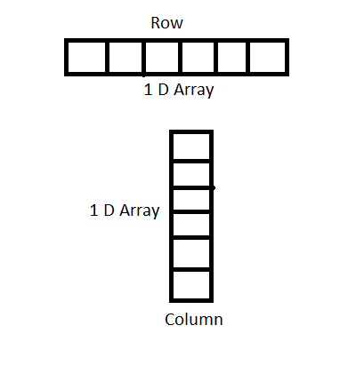

**2.Two dimensional array : In which it has two subscripts generally these are used for matrix**

**Operations.**

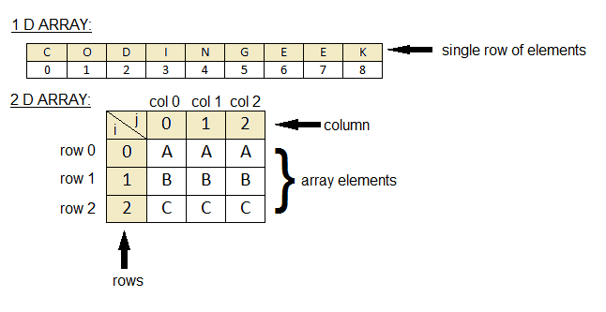

**3.Multidimensional array.**

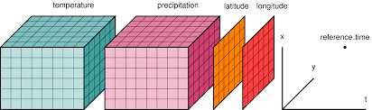

**Representation of array in java and syntax:**

**Single dimensional array representation ,syntax:**

int intArray[];

or int[] intArray;

// Creating an Java two dimensional Array

anStudentArray = new int[5][3];

**6. Steps for experiment/practical:**

* Firstly we need to create arrays for employee details, employee id, date of joining,

Basic,hra,da and allocate the values to the arrays and then after inserting the values.

* Now we need to allocate the designation in switch case and also followed by it .
* Secondly after all the allocating those values and now you assign the formula to calculate salary “Salary = Basic+HRA+DA-IT “
* Finally give the code in order to print the output.
* Now OPEN the command prompt Type cd Desktop and then you go to notepad and save the entire code into desktop and now in enter “Javac Employedetails.java” and press enter.
* Now enter the “Java Employedetails id(id = anything id that is declared in program)

Finally you will get the details of the id you entered

**6. Steps for experiment/practical:**

import java.util.*;

public class Main

{

public static void main(String[] args)

{

Scanner sc= new Scanner(System.in);

int f=0,pos =0,da=0,salary;

String des=null;

char empDes=' ';

String empid[]={"1001","1002","1003","1004","1005"};

String depName[]={"PL","ACCOUNTS","HR","AIT","MANAGING"};

String empName[]={"ravi","Avisha","Parikshit","ANSHIKA","SIYA",};

String dateJoin[]={"1/04/2009","7/04/20011","19/04/2009","21/05/2013","1/05/2010"};

int basic[]={25600,21700,32100,54800,13500};

int hra[]={8450,3560,2600,49900,2400};

int it[]={3450,1000,1200,2509,600};

char descodes[]={'a','b','c','d','e'};

System.out.println("Enter the employee id for cal the salary");

String a= sc.next();

for(int i=0;i<empid.length;i++)

{

if(empid[i].equals(a))

{

f=1;

pos=i;

empDes= descodes[i];

break;

}

}

if(f==0)

{

System.out.println("EMPLOYEE ID ENTERED IS WRONG");

}

else

{

switch(empDes)

{

case 'a':

des="ENGINEER";

da=20000;

break;

case 'b':

des="CONSULTANT";

da=28000;

break;

case 'c':

des="CLERK";

da=35000;

break;

case 'd':

des="RECEPTIONIST";

da=36000;

break;

case 'e':

des="MANAGER";

da=45000;

}

salary=(basic[pos]+hra[pos]+da)-it[pos];

System.out.println("EMPLOYEE ID"+"\t"+"EMPLOYEE NAME"+"\t"+"DEPARTEMENT NAME"+"\t"+"DESIGNATION"+"\t"+"SALARY");

System.out.println(empid[pos]+"\t\t"+empName[pos]+"\t\t\t"+depName[pos]+"\t\t"+des+"\t"+salary);

}

}

}

**7. Observations/Discussions(For applied/experimental sciences/materials based labs):**

**8. Percentage error (if any or applicable):**

**NO percentage error**

**9. Calculations/ Chemical Reactions / Theorems /Formulas used etc :**

Salary calculated as (Basic+HRA+DA-IT)

**10. Result/Output/Writing Summary:**

**By adding the employee ID as input then we get information about its salary and printing the employee desgitation**

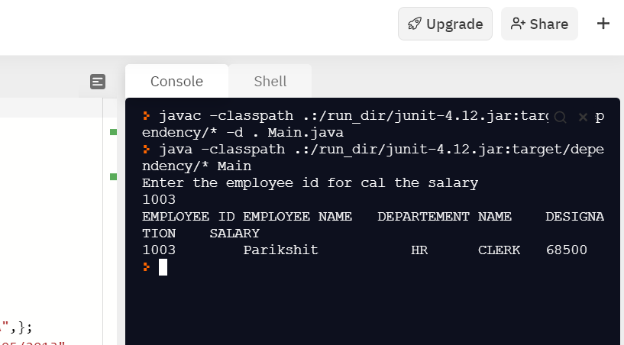

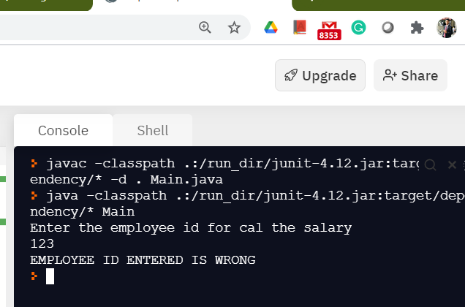

**11. Graphs (If Any): Image /Soft copy of graph paper to be attached here**

**NO graph attached.**

**Learning outcomes (What I have learnt):**

**1.take input from the user and print employee information using array**

**2.basic formula to calculate the salary of the employee**

**3.use java compiler**

**4.Use of the for loop**

**5.Use of Switch-case**

**Evaluation Grid (To be created as per the SOP and Assessment guidelines by the faculty):**

|  |  |  |  |
| --- | --- | --- | --- |
| Sr. No. | Parameters | Marks Obtained | Maximum Marks |
| 1. |  |  |  |
| 2. |  |  |  |
| 3. |  |  |  |
|  |  |  |  |